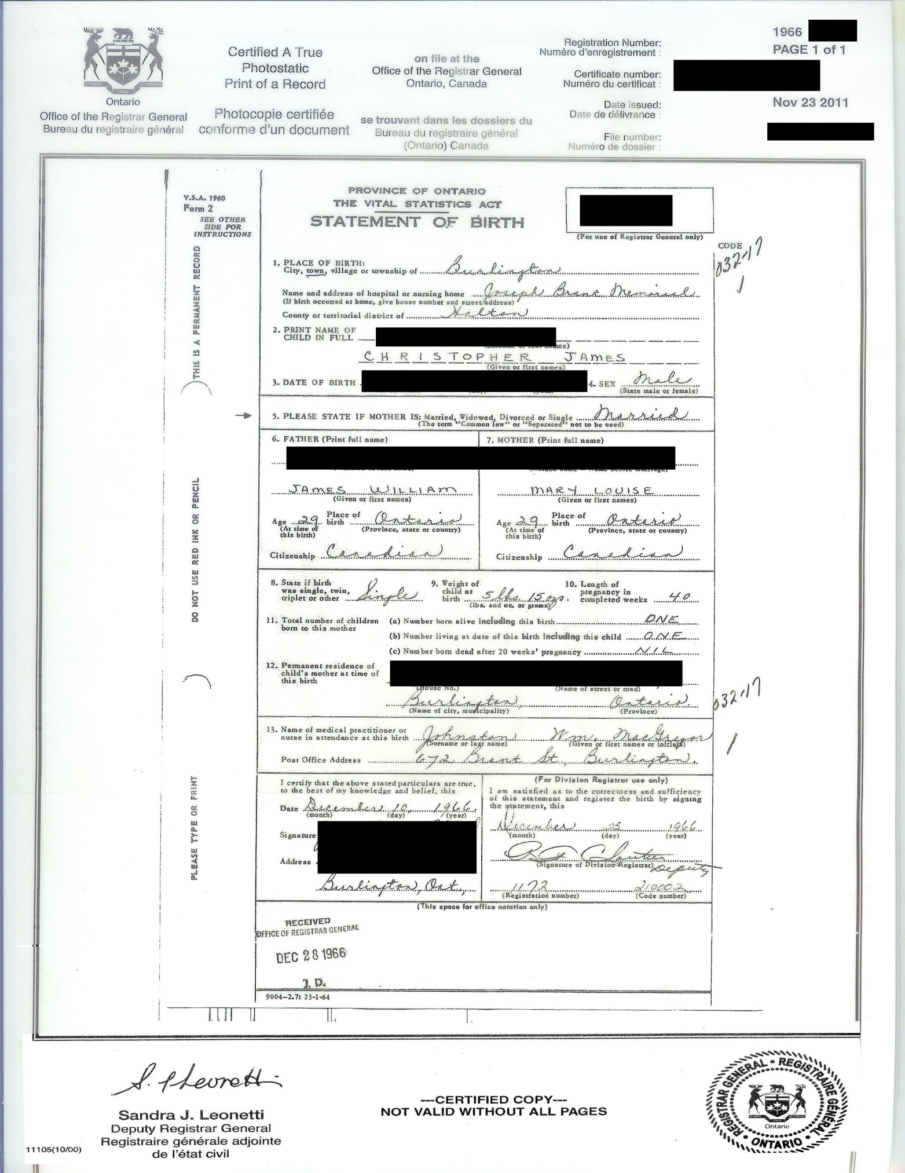
This is the original [founding] document you acquire from the service corporation [Gov] registrar general office
It will be different in other countries and within Canada depending when and where you are born
This is where you get the information for other 2 pages that complete the Correct ID package

